ECE 231L Project 3 Documentation

Step One: Understanding project files and framework

Step Two: Compiling and executing without any added solutions

* Provided compilation command in Acequia Manager Guide produced errors.

G++ TopMain.cpp with ./TopMain.cpp

* Required to enter the following:

g++ -std=c++11 -o TopMain TopMain.cpp

Step Three: Begin entering solutions in StudentSolutions.cpp file.

* Simple for loop that runs through each region to open/set canal flow

Step Four: Receive no consistent positive scores. Begin to notice fine details that affect randomized outcomes.

* Need for hourly iteration to help avoid region overflow floods when canal is open. If conditions normalize, canals set to close.

Step Five: Need for dynamic flow rates to fine tune hourly iteration in preceding step four.

Step Six: Prioritize regions in need of most water.

Step Seven: Brainstorm/reflect on topics covered during semester to examine any possible options not yet explored or used in Student Solutions.

* Send email to professor for tips or hints.
* Inquire about random generator setting game environment.

Step Eight: Receive email reply and implement suggestions.

Step Nine: Change project construct files like AcequiaManager.cpp and TopMain.cpp to pinpoint areas affecting score, randomness, etc.

* Constraining the time range to a specific value. Results are slightly more consistent.

Step Ten: Return everything to original settings, implemented new TopMain.cpp provided by Mr Jack Martin. No longer receiving negative scores, typically see 20-80 score.

* Screenshots of inconsistencies or instances where score received did not reflect success of student solutions below prior to new TopMain.

Here, we receive optimal water levels before solution simulation is run. No change to water levels (no action taken). Score remains less than perfect.

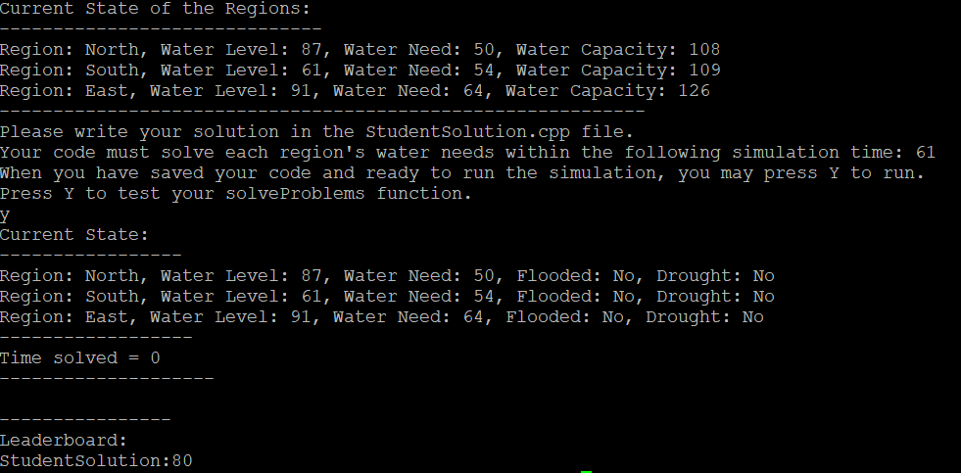

Here, we receive water levels too low to have any chance of successful simulation. Not enough water to meet water needs.

East water region drought resolved. All water levels meet needs. Score still not reflective of ideal outcome.

